Lab 8 Deliverables

Daniel Canterino djc3323

Pranav Padmanabha pp9638

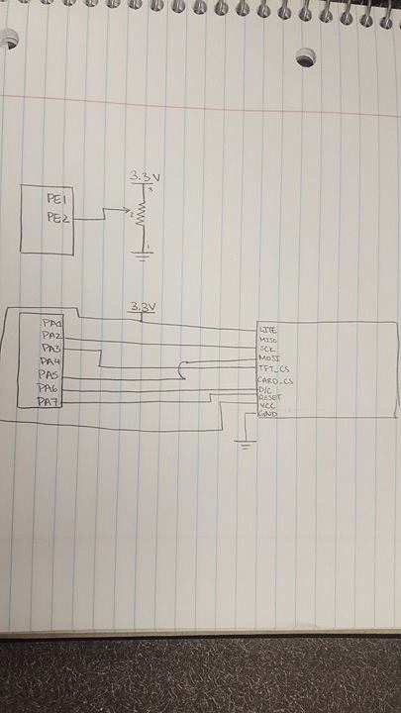

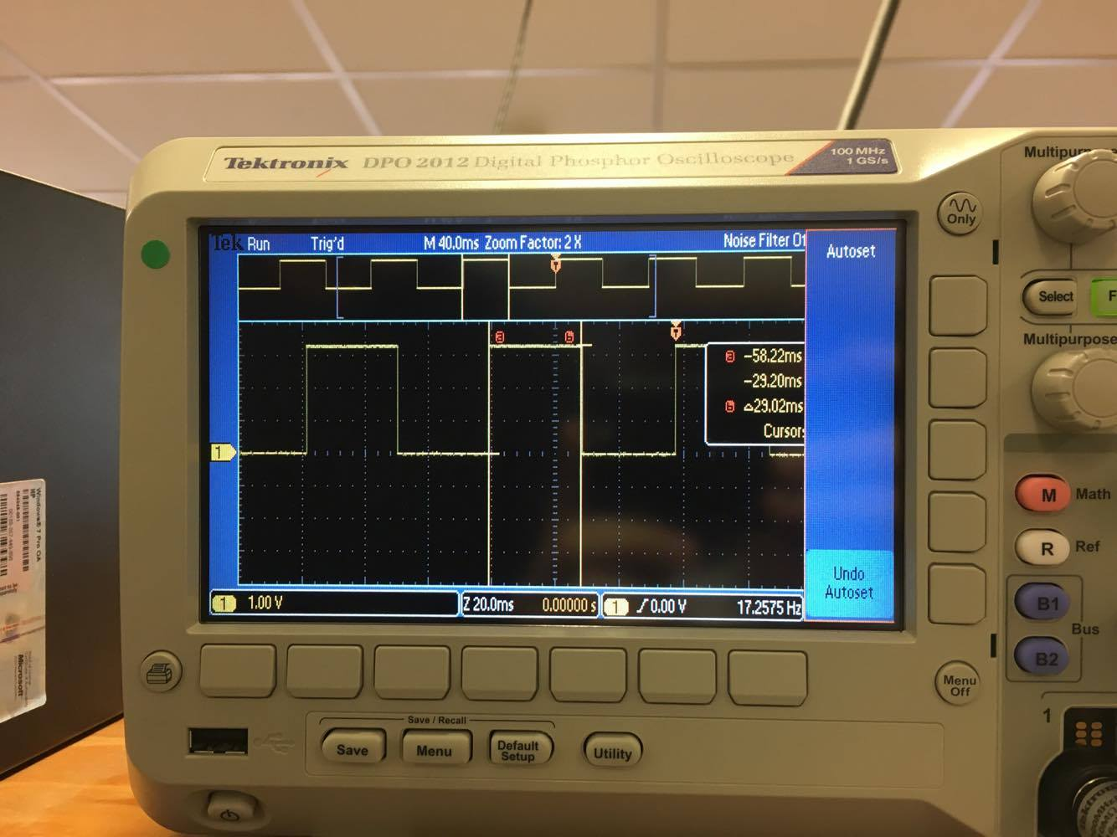

|  |  |  |
| --- | --- | --- |
| Analog Input | reading | point in .001cm |
| 0.24 | 0 | 0 |
| 1.12 | 322 | 500 |
| 2.05 | 1616 | 1000 |
| 2.92 | 3192 | 1500 |
| 3.28 | 4092 | 2000 |

// Lab8.c

// Runs on LM4F120 or TM4C123

// Student names: Pranav Padmanabha and Daniel Canterino

// Last modification date: 4/8/2017

// Last Modified: 4/5/2016

// Analog Input connected to PE2=ADC1

// displays on Sitronox ST7735

// PF3, PF2, PF1 are heartbeats

#include <stdint.h>

#include "ST7735.h"

#include "TExaS.h"

#include "ADC.h"

#include "print.h"

#include "tm4c123gh6pm.h"

//*****the first three main programs are for debugging *****

// main1 tests just the ADC and slide pot, use debugger to see data

// main2 adds the LCD to the ADC and slide pot, ADC data is on Nokia

// main3 adds your convert function, position data is no Nokia

void DisableInterrupts(void); // Disable interrupts

void EnableInterrupts(void); // Enable interrupts

#define PF1 (*((volatile uint32_t *)0x40025008))

#define PF2 (*((volatile uint32_t *)0x40025010))

#define PF3 (*((volatile uint32_t *)0x40025020))

// Initialize Port F so PF1, PF2 and PF3 are heartbeats

#define PD0 (*((volatile uint32_t *)0x40007004))

volatile uint32_t Counts;

int ADCmail;

int ADCstatus;

void PortF_Init(void){

SYSCTL_RCGCGPIO_R|=0x20;

GPIO_PORTF_LOCK_R=GPIO_LOCK_KEY;

GPIO_PORTF_CR_R|=0x0E;

GPIO_PORTF_DIR_R|=0x0E;

GPIO_PORTF_DEN_R|=0x0E;

GPIO_PORTF_AFSEL_R&=~(0x0E);//turn on pf123 for heartbeats, no inputs, only outputs, disable af and am

GPIO_PORTF_AMSEL_R&=~(0x0E);

GPIO_PORTF_PCTL_R&=~(0x0E);

}

uint32_t Data; // 12-bit ADC

uint32_t Position; // 32-bit fixed-point 0.001 cm

int main1(void){ // single step this program and look at Data

TExaS_Init(); // Bus clock is 80 MHz

ADC_Init(); // turn on ADC, set channel to 1

while(1){

Data = ADC_In(); // sample 12-bit channel 1

}

}

int main2(void){

TExaS_Init(); // Bus clock is 80 MHz

ADC_Init(); // turn on ADC, set channel to 1

ST7735_InitR(INITR_REDTAB);

PortF_Init();

while(1){ // use scope to measure execution time for ADC_In and LCD_OutDec

PF2 = 0x04; // Profile ADC

Data = ADC_In(); // sample 12-bit channel 1

PF2 = 0x00; // end of ADC Profile

ST7735_SetCursor(0,0);

PF1 = 0x02; // Profile LCD

LCD_OutDec(Data);

ST7735_OutString(" "); // these spaces are used to coverup characters from last output

PF1 = 0; // end of LCD Profile

}

}

uint32_t Convert(uint32_t input){

input=((4373*input)+1984300)/10000; ///NEED TO STABILIZE DATA AND GET DATA FOR LINE, RIGHT NOW IT IS NOT LINEAR

return input;

}

int main3(void){

TExaS_Init(); // Bus clock is 80 MHz

ST7735_InitR(INITR_REDTAB);

PortF_Init();

ADC_Init(); // turn on ADC, set channel to 1

while(1){

PF2 ^= 0x04; // Heartbeat

Data = ADC_In(); // sample 12-bit channel 1

PF3 = 0x08; // Profile Convert

Position = Convert(Data);

PF3 = 0; // end of Convert Profile

PF1 = 0x02; // Profile LCD

ST7735_SetCursor(0,0);

LCD_OutDec(Data); ST7735_OutString(" ");

ST7735_SetCursor(6,0);

LCD_OutFix(Position);

PF1 = 0; // end of LCD Profile

}

}

void SysTick_Init(uint32_t period){

NVIC_ST_CTRL_R = 0; //disable the interrupt during setup

NVIC_ST_RELOAD_R = period - 1; //reload value (2*10^6)

NVIC_ST_CURRENT_R = 0; //clears data in current

NVIC_SYS_PRI3_R = (NVIC_SYS_PRI3_R&0x00FFFFFF)|0x40000000; //priority 2

NVIC_ST_CTRL_R = 0x00000007; //Enable the interrupts

}

void SysTick_Handler(void){

GPIO_PORTF_DATA_R^=0x02;//toggles pf1

GPIO_PORTF_DATA_R^=0x04;//toggles pf2

Data= ADC_In();//sets data equal to the adc input

ADCmail=Data;//sets global variable adcmail to adc input

ADCstatus=1;//sets global variable adcstatus to 1 to indicate there is new data available

GPIO_PORTF_DATA_R^=0x08;//toggles pf3

}

int main(void){

TExaS_Init();

// your Lab 8

ST7735_InitR(INITR_REDTAB);

PortF_Init();

ADC_Init(); // turn on ADC, set channel to 1

EnableInterrupts(); //enables interrupts after all initialization is complete

int output;

while(1){

SysTick_Init(1160000); //calls systick init with 2*10^6 ;;; 80MHz * 40Hz (1/40)

while(ADCstatus==0){//waits for systick handler to set adc status to 1 indicating fresh data

}

output=Convert(ADCmail);// calls convert on the adc data stored at the global variable --> converts to cm stores to output

ST7735_SetCursor(0,0);

LCD_OutDec(ADCmail); //assembly function out dec

ST7735_OutString(" ");

ST7735_SetCursor(6,0);

LCD_OutFix(output); //assembly function outfix

ST7735_OutString(" cm");

ADCstatus=0; //resets adc status to 0

}

}

// ADC.c

// Runs on LM4F120/TM4C123

// Provide functions that initialize ADC0

// Last Modified: 3/6/2015

// Student names: change this to your names or look very silly

// Last modification date: change this to the last modification date or look very silly

#include <stdint.h>

#include "tm4c123gh6pm.h"

// ADC initialization function

// Input: none

// Output: none

void ADC_Init(void){

SYSCTL_RCGCGPIO_R|=0x10;//port e initialiation, pe2 is input, no outputs, enable alternate function and analong function on pe2, disable i/o function

while ((SYSCTL_PRGPIO_R&0x10) ==0){};//2 cycles

GPIO_PORTE_DIR_R&=~(0x04);

GPIO_PORTE_AFSEL_R|=(0x04);

GPIO_PORTE_DEN_R&=~(0x04);

GPIO_PORTE_AMSEL_R|=(0x04);

SYSCTL_RCGCADC_R|=0x01;//activate adc0

while ((SYSCTL_RCGCADC_R&0x01)==0){}; //4 cycles

ADC0_PC_R=0x01;//configure for 125K

ADC0_SSPRI_R=0x0123;//sequencer 3 is highest priority

ADC0_ACTSS_R&=~(0x0008);//disable sample sequencer 3

ADC0_EMUX_R&=~(0xF000);//seq3 is software trigger

ADC0_SSMUX3_R=(ADC0_SSMUX3_R & 0xFFFFFFF0) +1;//clear ss3 field and set channel ain0 (pe2)

ADC0_SSCTL3_R= (0x0006);//no ts0 d0, yes ie0 end0

ADC0_IM_R &= ~(0x0008);//disable ss3 interrupts

ADC0_ACTSS_R |= (0x0008);//enable sample sequencer 3

ADC0_SAC_R=0x04;//AVERAGES 16 SAMPLES NOW

}

//------------ADC_In------------

// Busy-wait Analog to digital conversion

// Input: none

// Output: 12-bit result of ADC conversion

uint32_t ADC_In(void){

uint32_t result;

ADC0_PSSI_R = 0x0008;//initiate ss3

while ((ADC0_RIS_R & 0x08) == 0){//wait for conversion done

}

result=(ADC0_SSFIFO3_R & 0xFFF);//read 12-bit result

ADC0_ISC_R = 0x0008;//acknowledge completion

return (result);

}

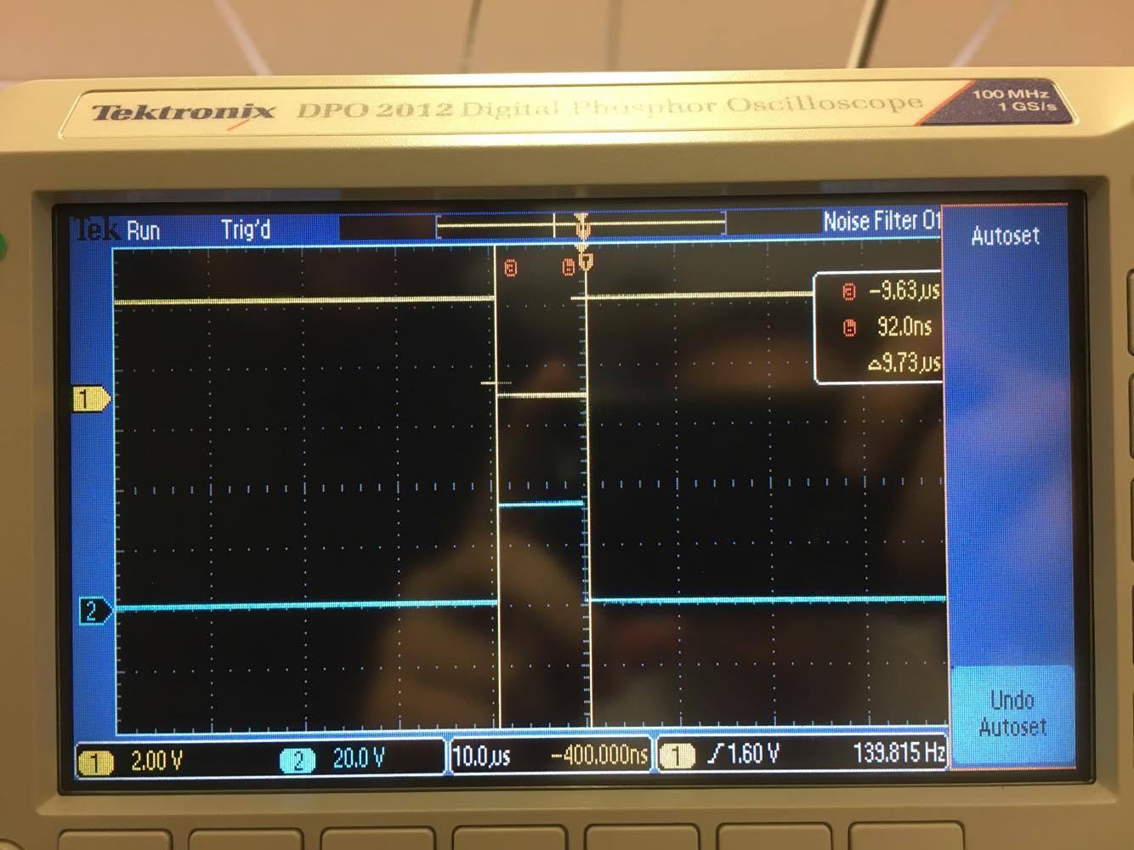

|  |  |  |
| --- | --- | --- |
| True Position xti | Measured Position xmi | Error xti-xmi |
| 1.17cm | 1.155cm | .015cm |
| .52cm | .489cm | .031cm |
| 1.68 | 1.709 | .011cm |
| .41cm | .319 | .091cm |
| .73cm | .738cm | .008cm |